We gathered at Chula Vista, CA for our third Epiphany trip after the passing of the founder Fr. Pat Travers, ss.cc. Our group was smaller than the previous two trips, but still very enthusiastic. It felt like Fr. Pat was looking out for us and with us the whole happy day. As president of the Tijuana Mission Project said: “It was a great day and very productive”.
We crossed the Otay border easily, with our van paying the impuestos right away with delay.
We got to the San Juan Diego chapel the Esperanza neighbor about 10 am in just as the parishioners were streaming out from the packed mass. They were happy to see us, and we were happy to see so many attending the mass. I hadn’t seen any Catholic chapel until we got there- but did see a few Pentecostal churches so wisdom of constructing the chapels is very apparent. Providential.
Our group of volunteers and the chapel volunteers quickly go to work setting up tables and the items to be distributed: toys, food staples and other necessities like clothes and blankets. We also gave away some rosaries made by Franschia a member of the HNM rosary making group.
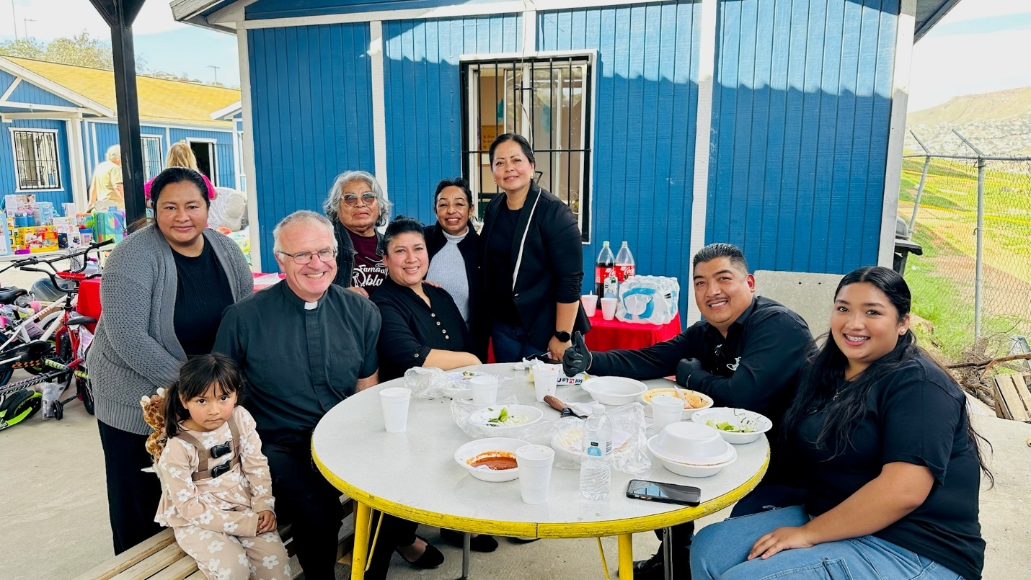
Rigoberto, one of the Tijuanas, had made menudo soup, and being the good missionary willing to eat whatever is set before me, I enjoyed this brunch. The little girl with the cat backpack came over to me and said “hello” in English. Her parents told me her name is Scarlett Victoria.
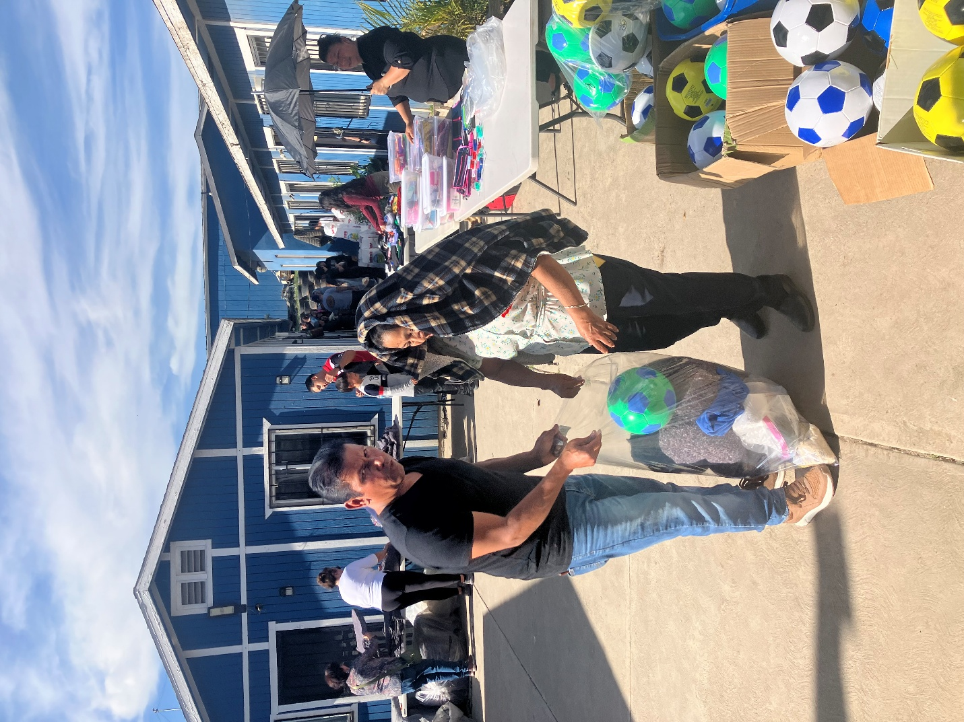
Alfredo, who helps with the construction of the homes there, came over to assist with the distribution. Currently, the homes are being built mostly by the men from Tijuana with the Tijuana Mission Project paying their salaries and bringing some supplies from the USA.
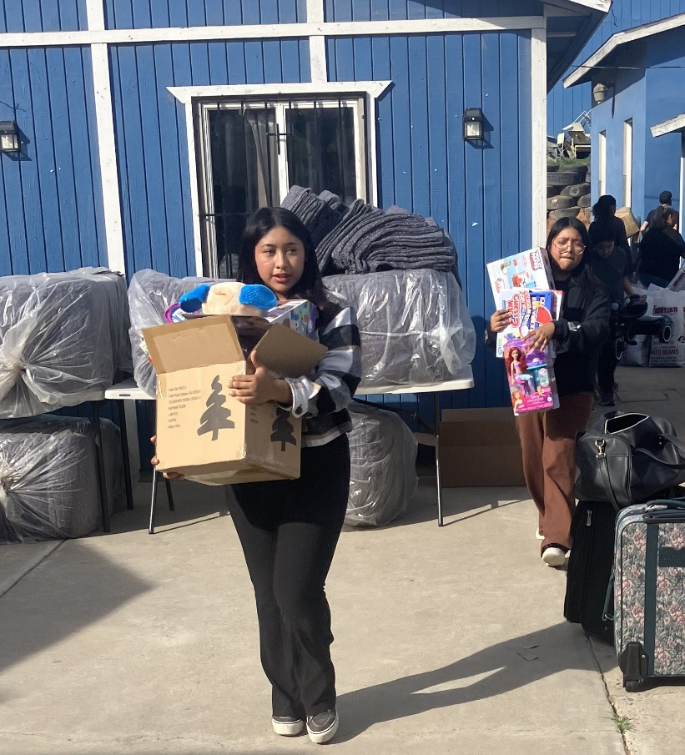

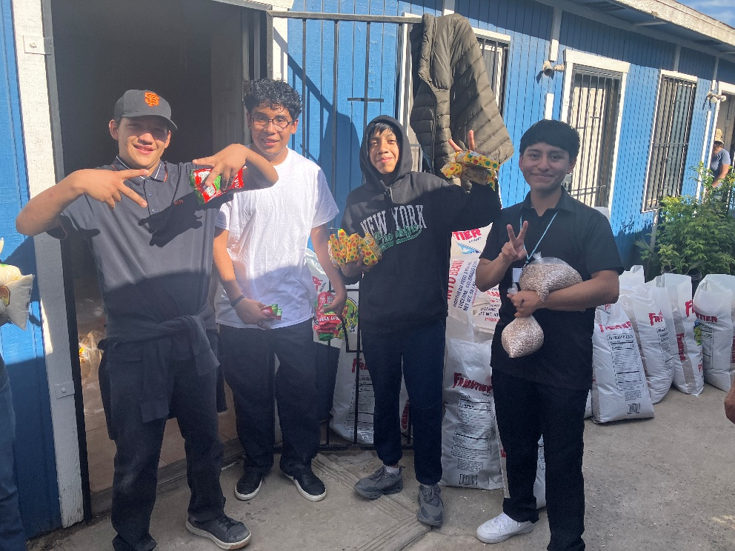
There was a group of Mexican teens, so similar our young men at Damien High, laughing, enjoying camaraderie, and being helpful. I am wondering where they will be in 10 years and how much this center of Catholic faith and charity will be an aid to them.
One of our volunteers shared a memory from the last Tijuana Mission trip with Fr. Pat- of him sitting in a chair watching the flurry of activity, and not wanting to leave.
After the distribution ended about 1 pm we had our Sunday mass. We offered the mass in honor of Fr. Pat and for our friendship/ brotherhood and sisterhood in Christ. Initially, we planned on it being mostly English, but as a good contingent from TJ entered as mass was beginning we adjusted to bilingual. The parishioners sang such beautiful, emotion-laiden songs.

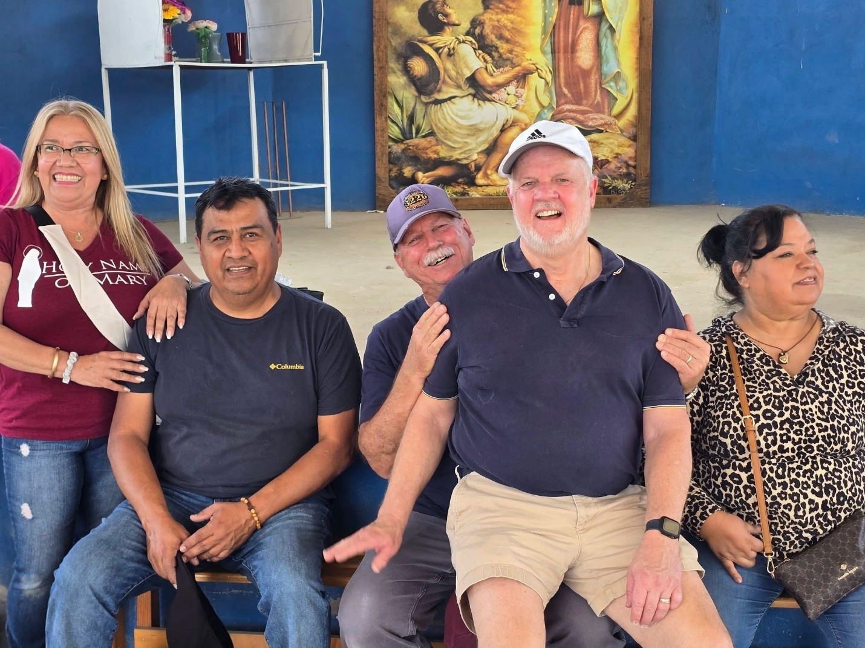
Celia Castro, from the Parish Council (far left), wrote: “Gracias por la invitación una vez más , asistir a estas misiones nos llena de gozo y satisfacción! Su homilía fue muy hermosa y humana , nos gustó cuando hizo relación a que todos somos un cuerpo de Cristo y que la frontera no nos puede dividir . Que unidos en Cristo todos formamos una familia y comunidad para la Gloria de Dios !”
After a bottleneck at an intersection, we quickly got to the border. As we entered the city near the Otay crossing, we were surprised to be sailing along. I thought we might have gotten in the express lane by accident. Instead of the 2.5 wait from 2 years ago and 1.5 hours from last year we waited only 30 minutes. While relieved, I had the creeping feeling that this had to do with the crack down on immigration- so perhaps not such a great thing after all.
Back in the U.S., Martha shared with me: “When people smile at us, we see the smile of God”. And Celia spoke of us being “the instruments of God, only God’s kids”.
We are grateful for the safe travel and beautiful time with our Mexican friends at the Juan Diego capilla. We are hoping that God can breath new life and send us new volunteers so we can continue this life giving charity and friendship. To this end, we are hoping we might present this Tijuana Mission Project to the Hispanic community and young adult ministry at HNM. Thank you, God, for this wonderful love-filled day. May you prosper this mission of Christ’s love!
